Project Planning Phase

Project Planning Template (Product Backlog, Sprint Planning, Stories, Story points)

Date | 8 November 2022
Team ID | PNT2022TMID20262
Project Name | Project - Inventory Management System for
 | Retailers
Maximum Marks | 8 Marks

Product Backlog, Sprint Schedule, and Estimation (4 Marks)

Sprint | Functional | User Story | User Story / Task | Story Points | Priority | Team Members
 | Requirement (Epic) | Number
Sprint-1 | Registration | USN-1 | As a user, I can register for the application by | 2 | High | A Vettriraam
 |  |  | entering my email, password, and confirming |  |  | J Jishnu
 |  |  | my password.
Sprint-1 | Registration | USN-2 | As a user, I can register for the application | 1 | High | J Karthick Raja  Karthick Saran
 |  |  | through E-mail
Sprint-1 | Confirmation | USN-3 | As a user, I will confirm the registration once I | 2 | Medium | A Vettriraam
 |  |  | have received the email from the application |  |  | J Jishnu
Sprint-1 | Login | USN-4 | As a user, I can log into the application by | 2 | High | J Karthick Raja  Karthick Saran
 |  |  | entering email & password
Sprint-2 | Dashboard | USN-5 | As user, I can view the dashboard of the | 3 | High | J Karthick Raja
  J Jishnu
 |  |  | application by entering my email & password
Sprint-2 | ChatBot | USN-6 | As a user, I can interact and get help from | 3 | Medium | J Jishnu
 |  |  | chatbot
Sprint-2 | Add items to cart | USN-7 | As a user, I can add the products I wish to buy | 3 | Medium | A Vetriraam  Karthick Saran
 |  |  | to the carts..
Sprint-3 | Stock Update | USN-8 | As a user, I can add products that are not | 5 | Medium | A Vetriraam
 |  |  | available in the dashboard to the stock list.
Sprint-4 | Request to Customer | USN-9 | As a user, I can post queries through mail | 5 | Low | KarthickSaran
 | Care
Sprint-4 | Feedback | USN-10 | As a user, I can give my feedback by submitting | 5 | Low | Karthick Raja J
 |  |  | the form.

Project Tracker, Velocity & Burndown Chart: (4 Marks)

Sprint | Total Story | Duration | Sprint Start Date |  | Sprint End Date |  | Story Points | Sprint Release Date
 | Points |  |  |  | (Planned) |  | Completed (as on | (Actual)
 |  |  |  |  |  |  | Planned End Date)
Sprint-1 | 7 | 6 Days | 24 | Oct 2022 | 29 | Oct 2022 | 7 | 29 | Oct 2022
Sprint-2 | 9 | 6 Days | 31 | Oct 2022 | 05 | Nov 2022 | 9 | 29 | Oct 2022
Sprint-3 | 5 | 6 Days | 07 | Nov 2022 | 12 | Nov 2022 | 5 | 12 | Nov 2022
Sprint-4 | 10 | 6 Days | 14 | Nov 2022 | 19 | Nov 2022 | 10 | 19 | Nov 2022

Velocity:

Imagine we have a 10-day sprint duration. The velocity of the team is 20 (points per sprint). Let’s calculate the team’s average velocity (AV) per iteration unit (story points per day)
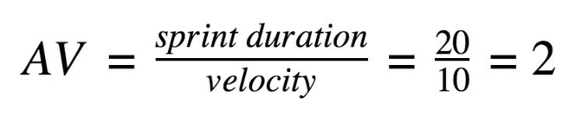
Sprints | Sprint Duration | Velocity | Actual velocity
Sprint-1 | 6 | 7 | 0.85
Sprint-2 | 6 | 9 | 0.66
Sprint-3 | 6 | 5 | 1.2
Sprint-4 | 6 | 10 | 0.6

SPRINT 1:
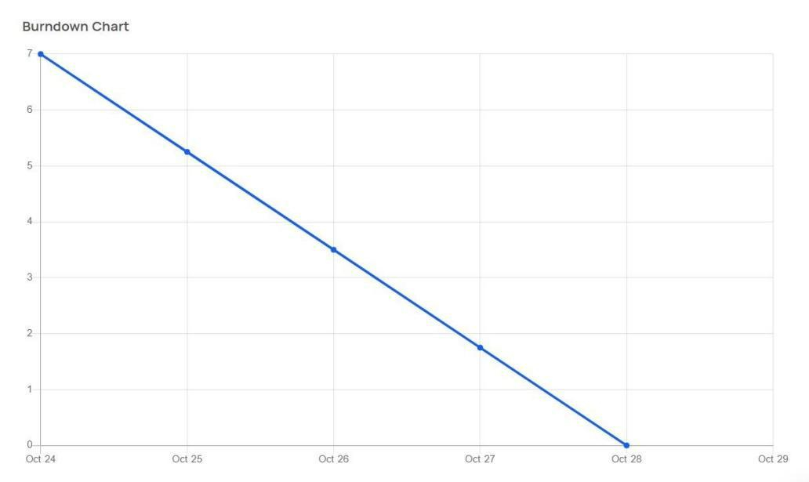
SPRINT 2:
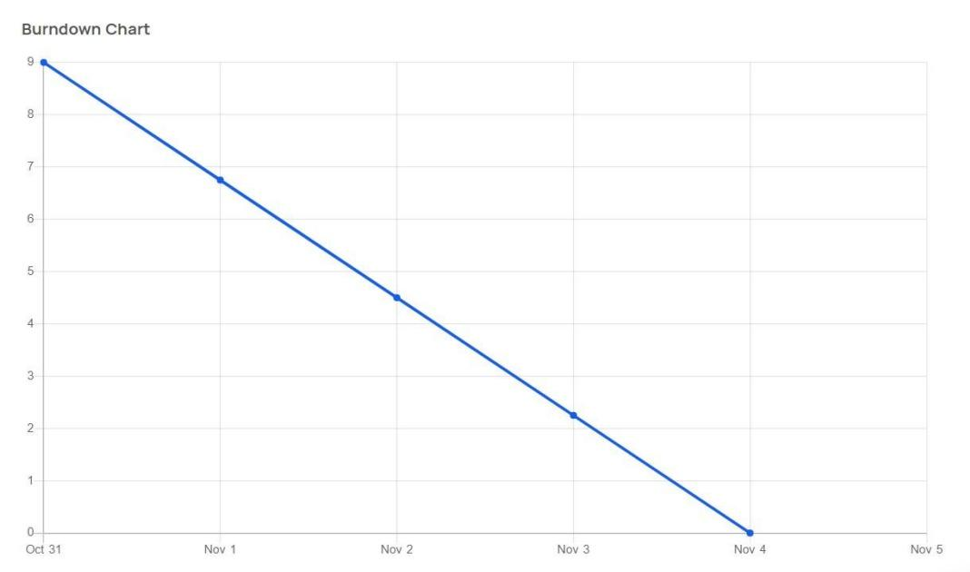
SPRINT 3:
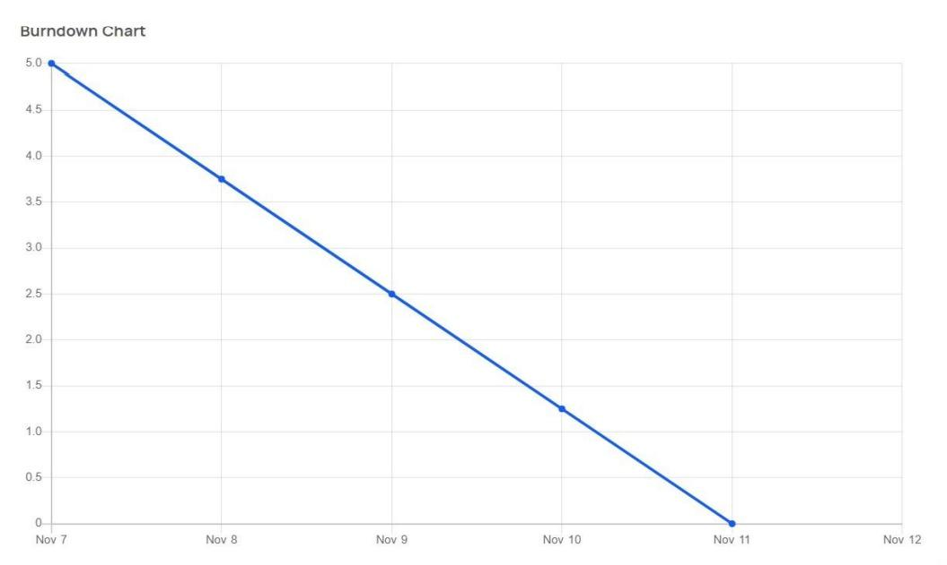
SPRINT 4:
